2. Search

1. A* by Nels Nelson

Heuristic function

[https://zh.wikipedia.org/wiki/A*%E6%90%9C%E5%AF%BB%E7%AE%97%E6%B3%95](https://zh.wikipedia.org/wiki/A*%E6%90%9C%E5%AF%BB%E7%AE%97%E6%B3%95)

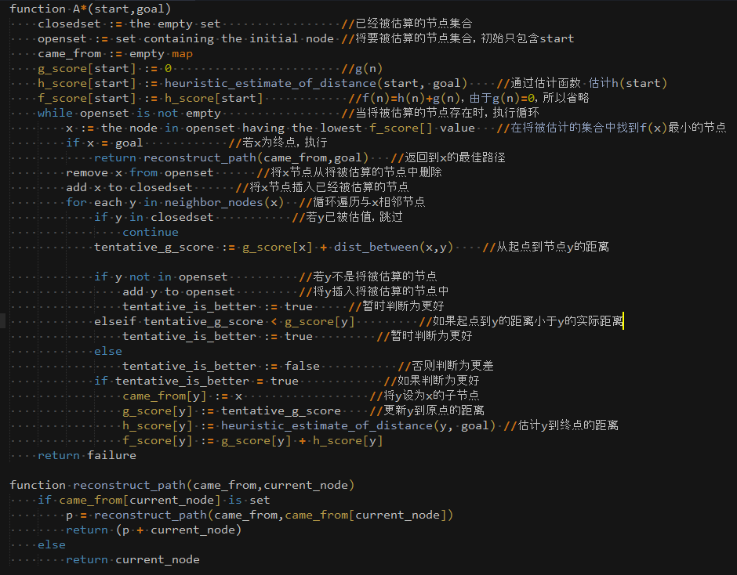

function A*(start,goal)

closedset := the empty set //已经被估算的节点集合

openset := set containing the initial node //将要被估算的节点集合，初始只包含start

came_from := empty map

g_score[start] := 0 //g(n)

h_score[start] := heuristic_estimate_of_distance(start, goal) //通过估计函数 估计h(start)

f_score[start] := h_score[start] //f(n)=h(n)+g(n)，由于g(n)=0，所以省略

while openset is not empty //当将被估算的节点存在时，执行循环

x := the node in openset having the lowest f_score[] value //在将被估计的集合中找到f(x)最小的节点

if x = goal //若x为终点，执行

return reconstruct_path(came_from,goal) //返回到x的最佳路径

remove x from openset //将x节点从将被估算的节点中删除

add x to closedset //将x节点插入已经被估算的节点

for each y in neighbor_nodes(x) //循环遍历与x相邻节点

if y in closedset //若y已被估值，跳过

continue

tentative_g_score := g_score[x] + dist_between(x,y) //从起点到节点y的距离

if y not in openset //若y不是将被估算的节点

add y to openset //将y插入将被估算的节点中

tentative_is_better := true //暂时判断为更好

elseif tentative_g_score < g_score[y] //如果起点到y的距离小于y的实际距离

tentative_is_better := true //暂时判断为更好

else

tentative_is_better := false //否则判断为更差

if tentative_is_better = true //如果判断为更好

came_from[y] := x //将y设为x的子节点

g_score[y] := tentative_g_score //更新y到原点的距离

h_score[y] := heuristic_estimate_of_distance(y, goal) //估计y到终点的距离

f_score[y] := g_score[y] + h_score[y]

return failure

function reconstruct_path(came_from,current_node)

if came_from[current_node] is set

p = reconstruct_path(came_from,came_from[current_node])

return (p + current_node)

else

return current_node

1. dynamic programming

3. prediction

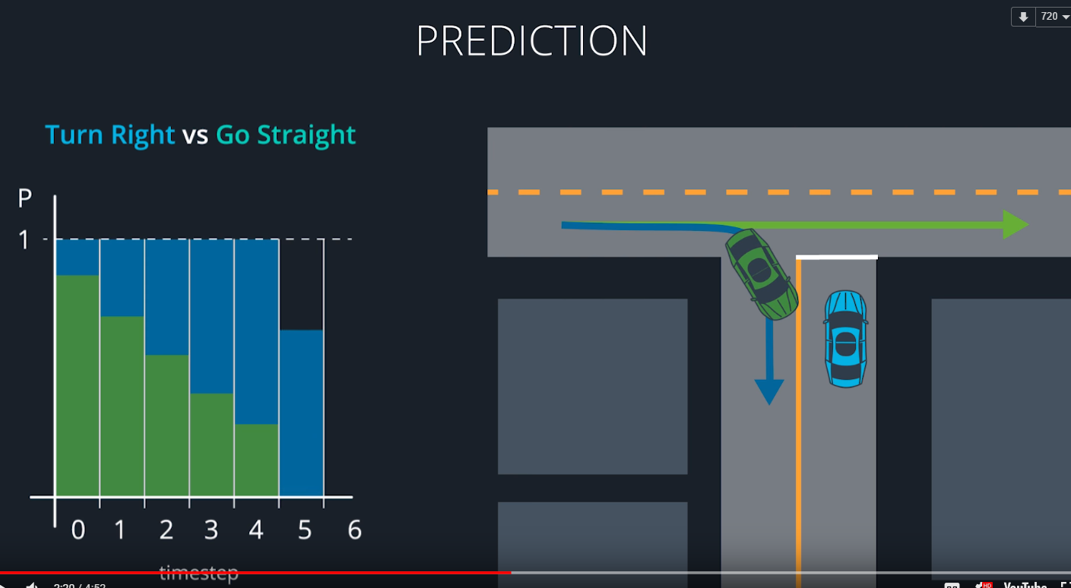

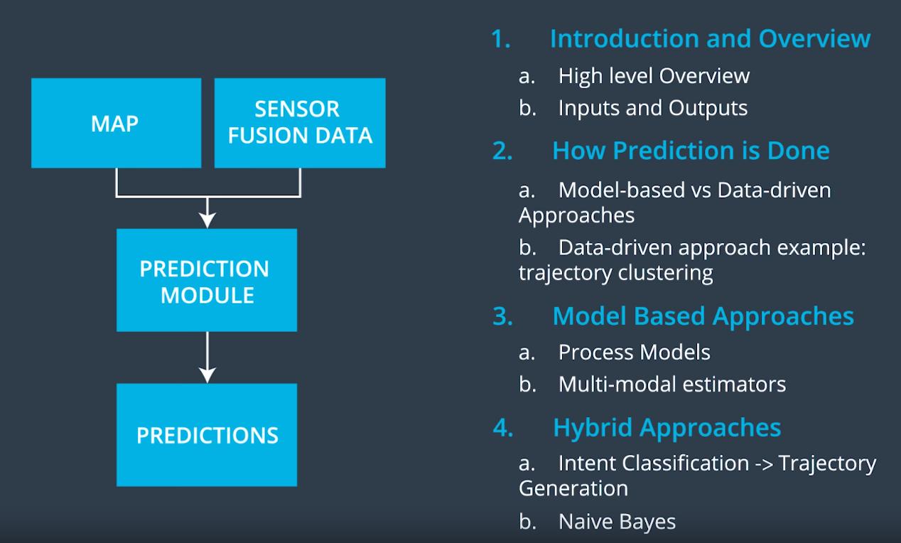

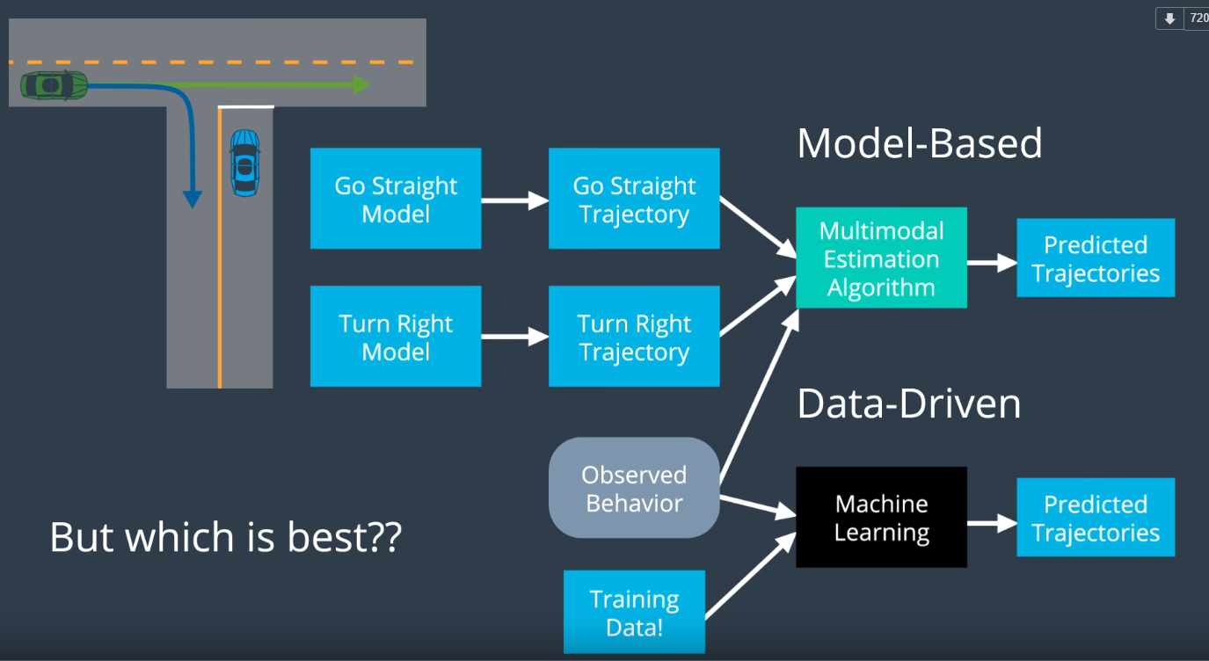

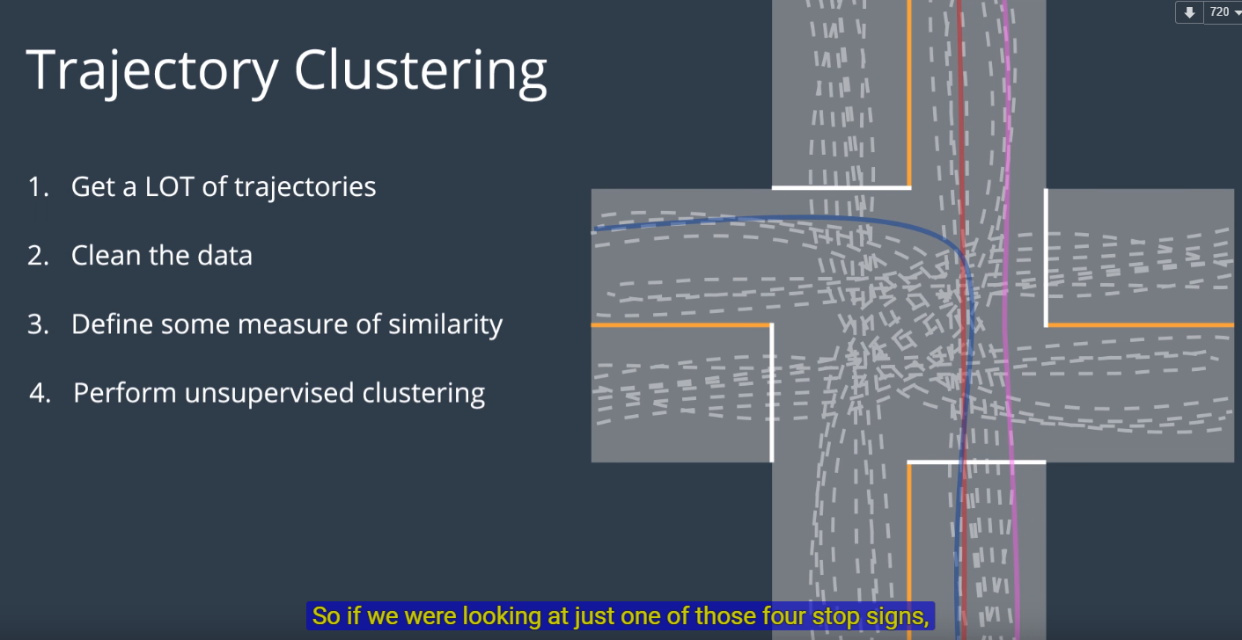

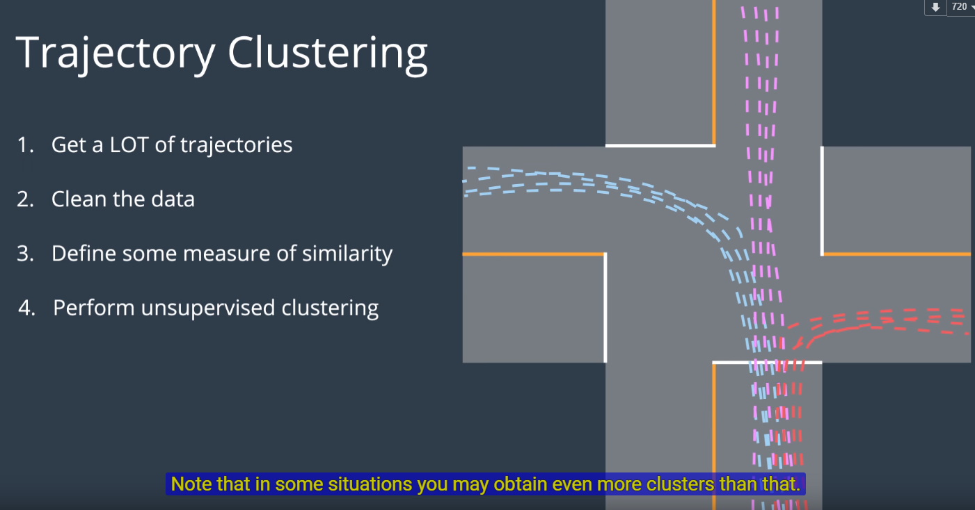

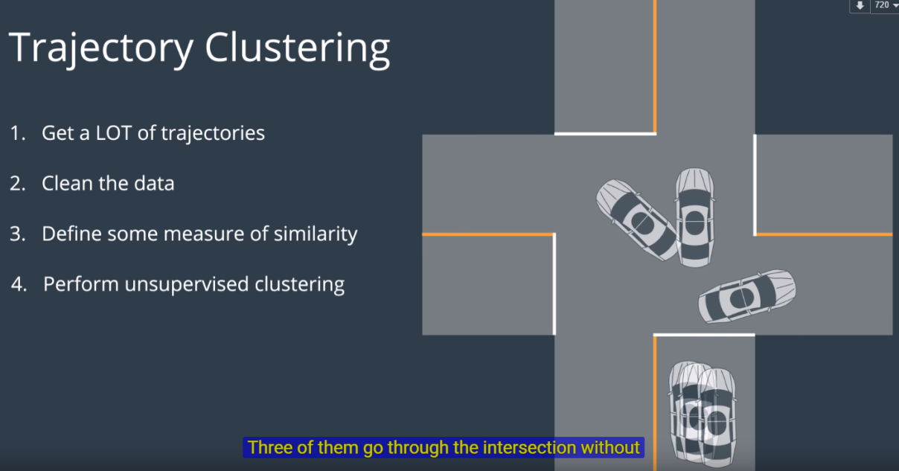

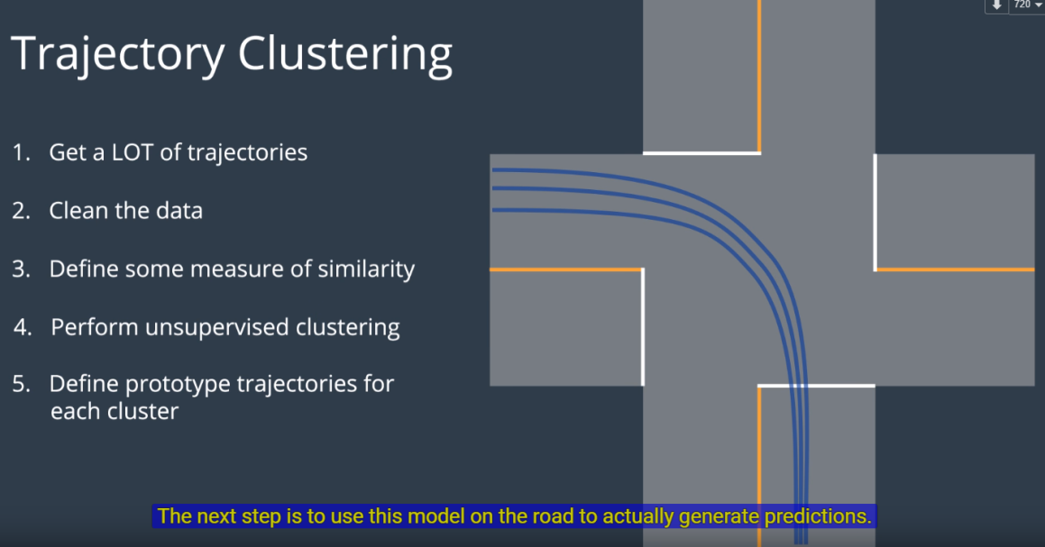

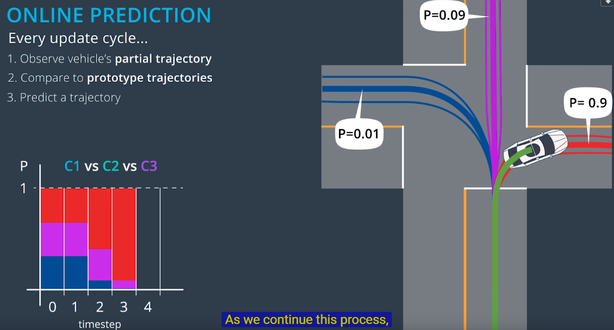

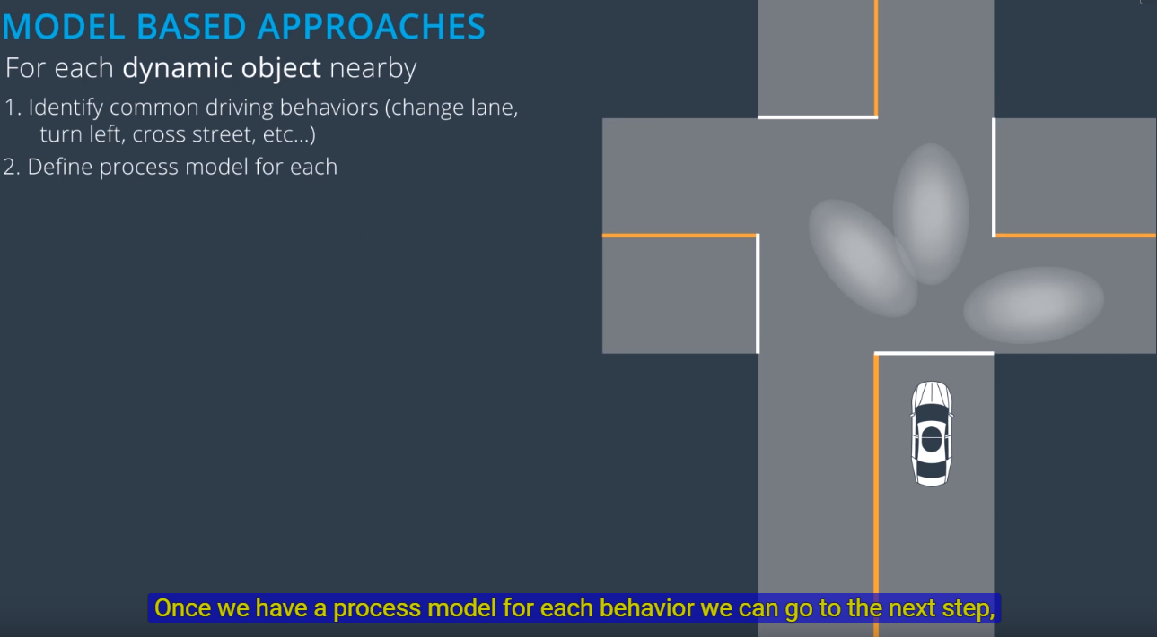

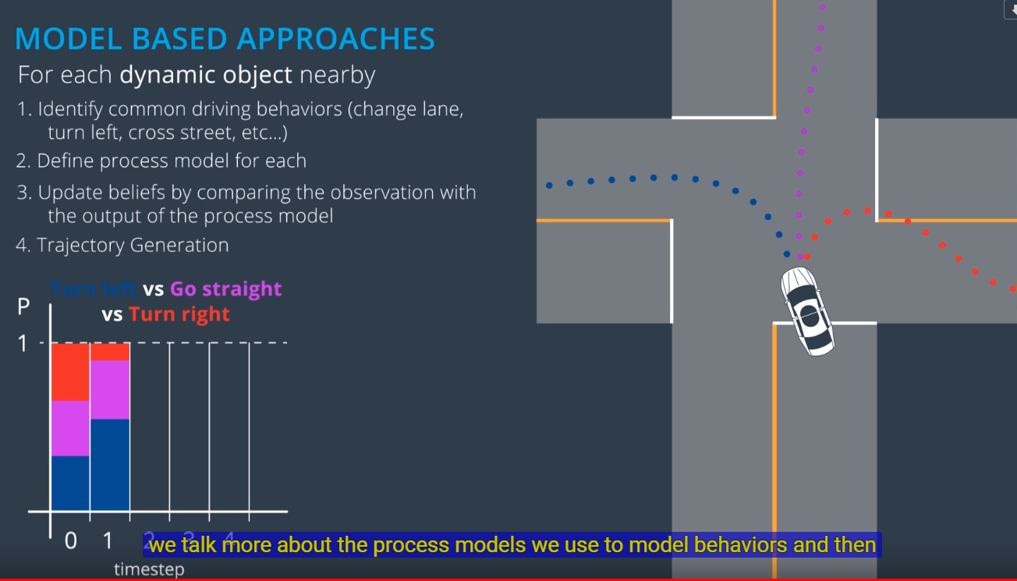

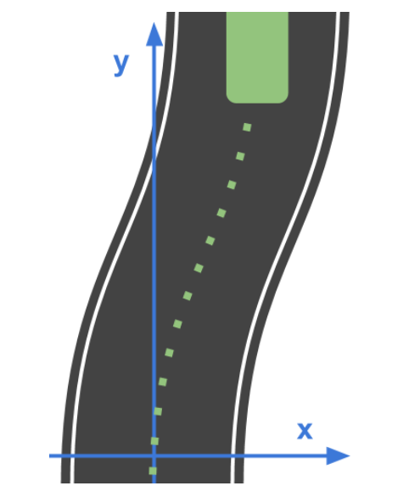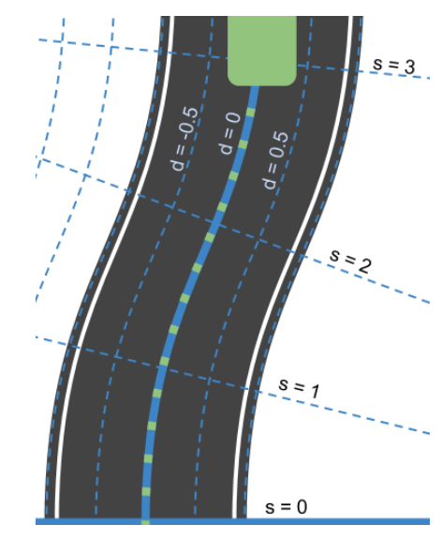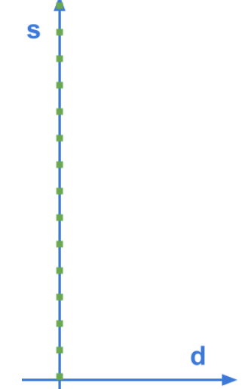

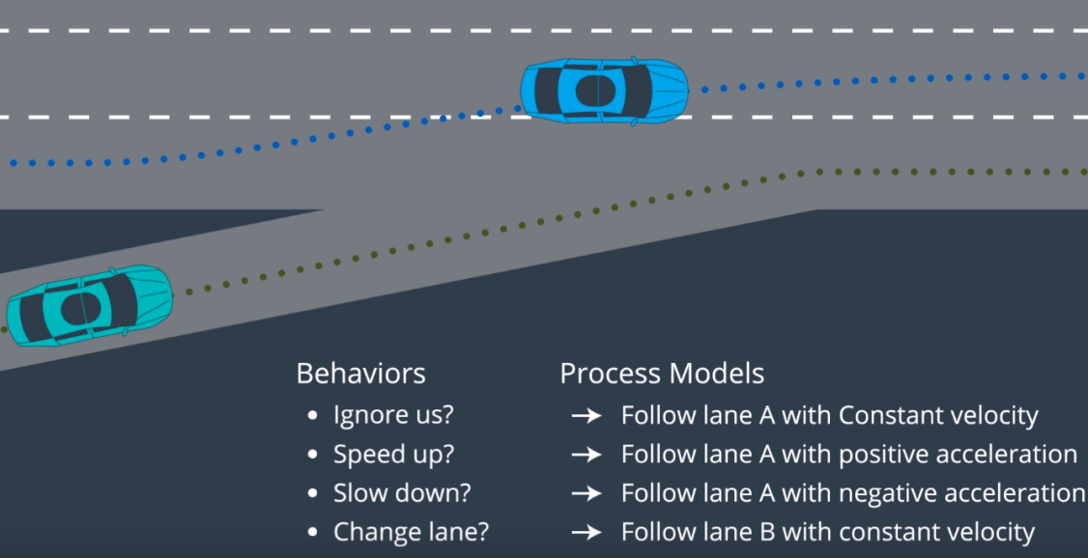

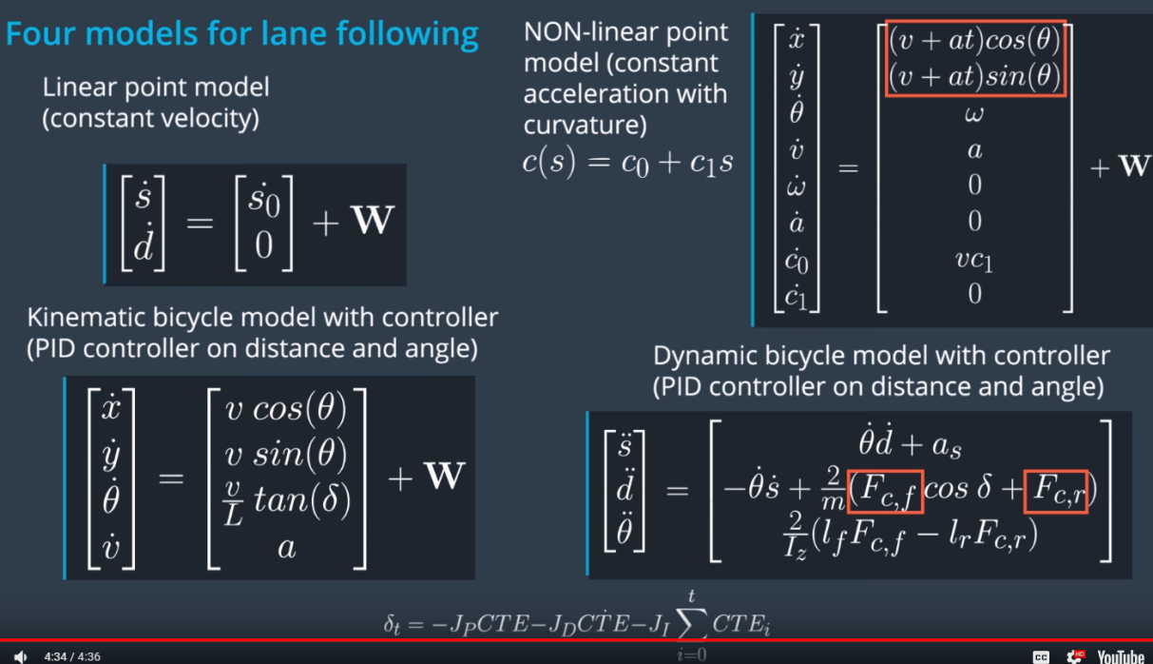

3.11 multimodel estimation

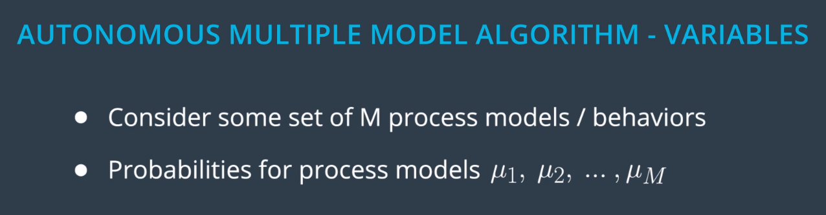

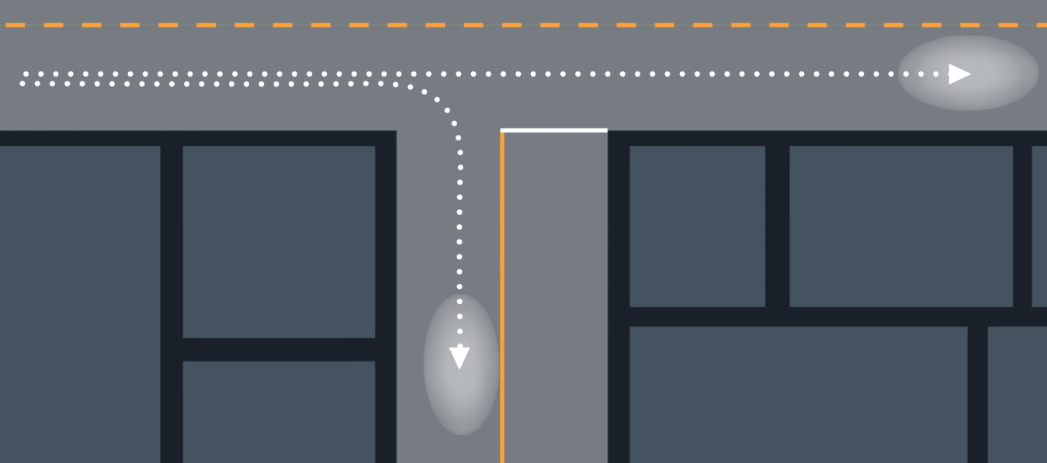

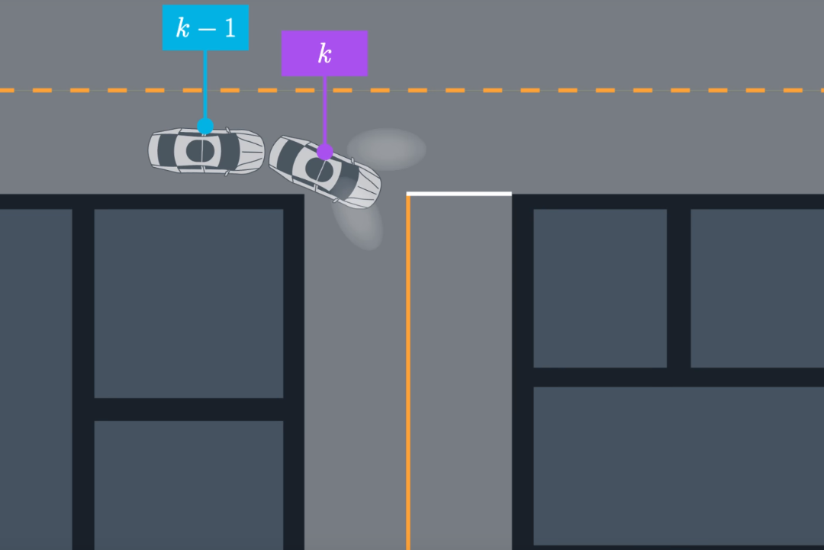

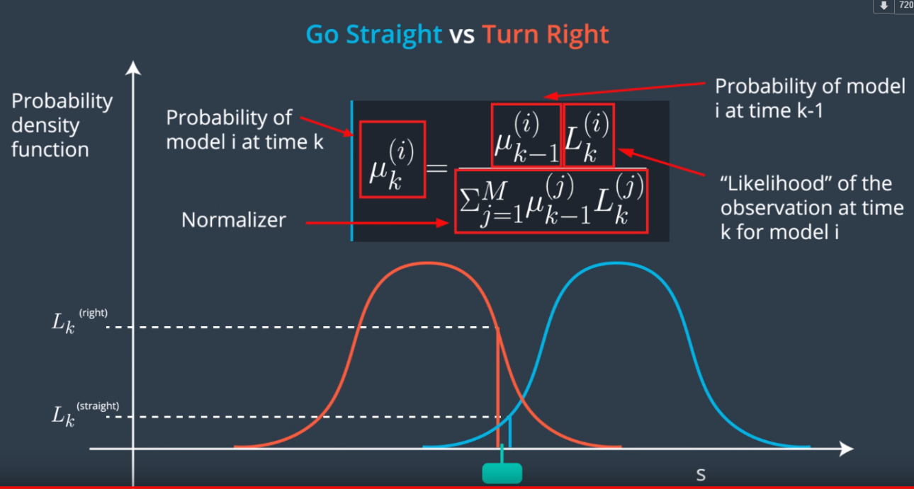

**1. Data-Driven Approaches**

Data-driven approaches solve the prediction problem in two phases:

1. Offline training
2. Online Prediction

**1.1 Offline Training**

In this phase the goal is to feed some machine learning algorithm a lot of data to train it. For the trajectory clustering example this involved:

1. **Define similarity** - we first need a definition of similarity that agrees with human common-sense definition.
2. **Unsupervised clustering** - at this step some machine learning algorithm clusters the trajectories we've observed.
3. **Define Prototype Trajectories** - for each cluster identify some small number of typical "prototype" trajectories.

**1.2 Online Prediction**

Once the algorithm is trained we bring it onto the road. When we encounter a situation for which the trained algorithm is appropriate (returning to an intersection for example) we can use that algorithm to actually predict the trajectory of the vehicle. For the intersection example this meant:

1. **Observe Partial Trajectory** - As the target vehicle drives we can think of it leaving a "partial trajectory" behind it.
2. **Compare to Prototype Trajectories** - We can compare this partial trajectory to the *corresponding parts* of the prototype trajectories. When these partial trajectories are more similar (using the same notion of similarity defined earlier) their likelihoods should increase relative to the other trajectories.
3. **Generate Predictions** - For each cluster we identify the most likely prototype trajectory. We broadcast each of these trajectories along with the associated probability (see the image below).

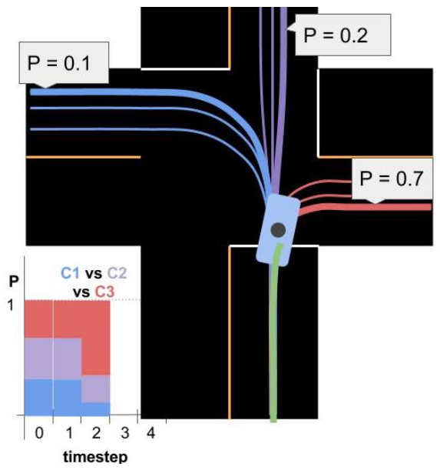

**2. Model Based Approaches**

You can think of model based solutions to the prediction problem as also having an "offline" and online component. In that view, this approach requires:

1. *Defining* process models (offline).
2. *Using* process models to compare driver behavior to what would be expected for each model.
3. *Probabilistically classifying* driver intent by comparing the likelihoods of various behaviors with a multiple-model algorithm.
4. *Extrapolating* process models to generate trajectories.

**2.1 Defining Process Models**

You saw how process models can vary in complexity from very simple...

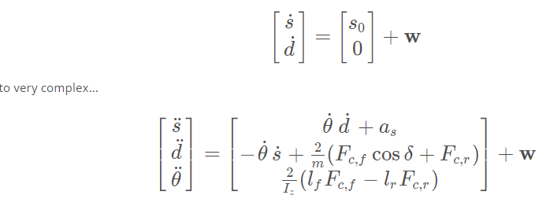

**2.2 Using Process Models**

Process Models are first used to compare a target vehicle's observed behavior to the behavior we would expect for each of the maneuvers we've created models for. The pictures below help explain how process models are used to calculate these likelihoods.

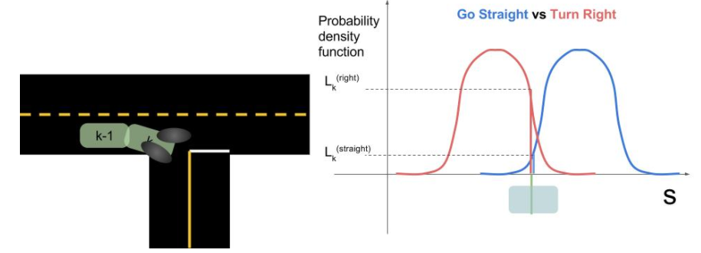

On the left we see two images of a car. At time k-1*k*−1 we predicted where the car would be if it were to go straight vs go right. Then at time k*k* we look at where the car actually is. The graph on the right shows the car's observed s*s* coordinate along with the probability distributions for where we *expected* the car to be at that time. In this case, the s*s* that we observe is substantially more consistent with turning right than going straight.

**2.3 Classifying Intent with Multiple Model Algorithm**

In the image at the top of the page you can see a bar chart representing probabilities of various *clusters* over time. Multiple model algorithms serve a similar purpose for model based approaches: they are responsible for maintaining beliefs for the probability of each maneuver. The algorithm we discussed is called the **Autonomous Multiple Model** algorithm (AMM). AMM can be summarized with this equation:

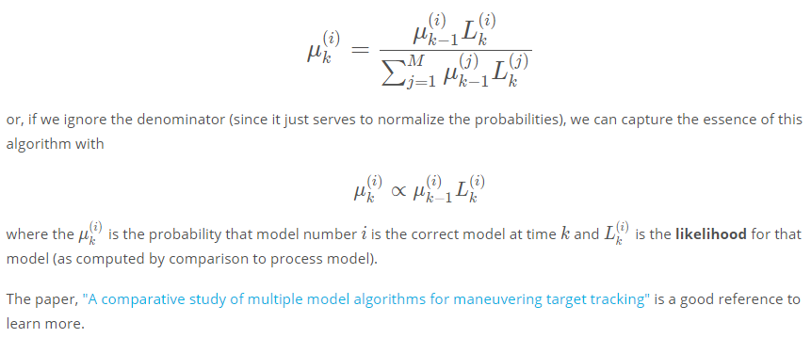

**2.4 Trajectory Generation**

Trajectory generation is straightforward once we have a process model. We simply iterate our model over and over until we've generated a prediction that spans whatever time horizon we are supposed to cover. Note that each iteration of the process model will necessarily add uncertainty to our prediction.

3.13 Hybrid A

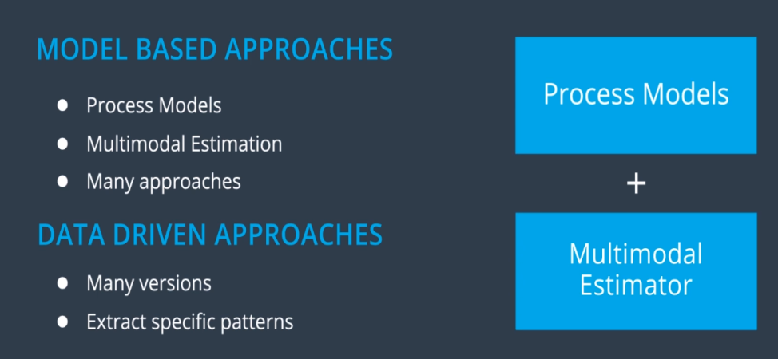

With a classifier e.g. Naïve Bayes Classifier

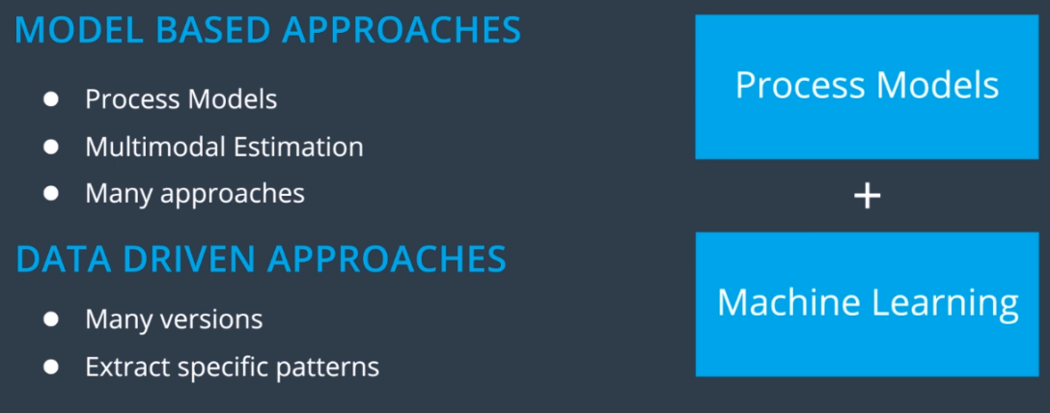

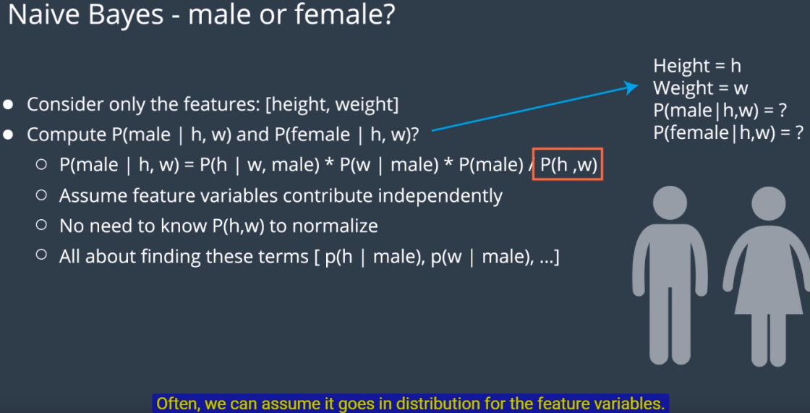

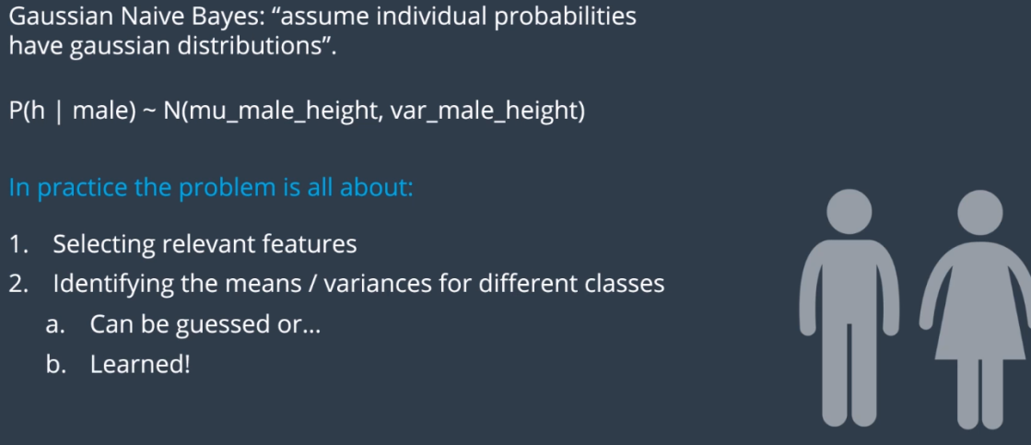

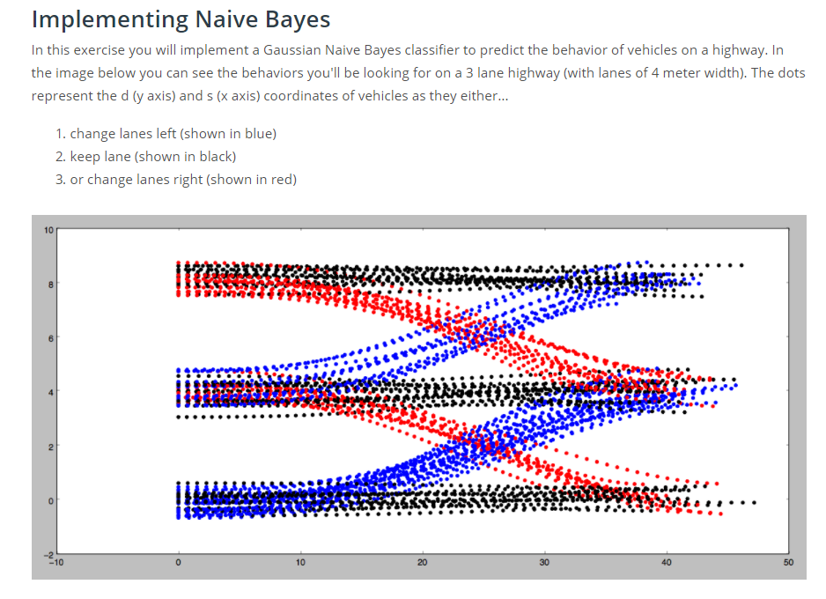

**Instructions**

1. Implement the train(self, data, labels) method in the class GNB in classifier.cpp.

Training a Gaussian Naive Bayes classifier consists of computing and storing the mean and standard deviation from the data for each label/feature pair. For example, given the label "change lanes left” and the feature \dot{s}*s*˙, it would be necessary to compute and store the mean and standard deviation of \dot{s}*s*˙ over all data points with the "change lanes left” label.

Additionally, it will be convenient in this step to compute and store the prior probability p(C_k) for each label C_k. This can be done by keeping track of the number of times each label appears in the training data.

1. Implement the predict(self, observation) method in classifier.cpp.

Given a new data point, prediction requires two steps:

* 1. **Compute the conditional probabilities for each feature/label combination**. For a feature x*x* and label C*C*with mean \mu*μ* and standard deviation \sigma*σ* (computed in training), the conditional probability can be computed using the formula [**here**](https://en.wikipedia.org/wiki/Naive_Bayes_classifier#Gaussian_naive_Bayes):

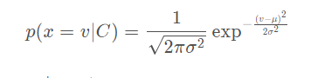

Here v*v* is the value of feature x*x* in the new data point.

1. **Use the conditional probabilities in a Naive Bayes classifier.** This can be done using the formula [**here**](https://en.wikipedia.org/wiki/Naive_Bayes_classifier#Constructing_a_classifier_from_the_probability_model):

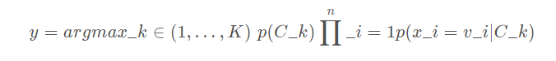

In this formula, the argmax is taken over all possible labels C_k*Ck*​ and the product is taken over all features x_i*xi*​ with values v_i*vi*​.

1. When you want to test your classifier, run Test Run and check out the results.

**NOTE**: You are welcome to use some existing implementation of a Gaussian Naive Bayes classifier. But to get the **best**results you will still need to put some thought into what **features** you provide the algorithm when classifying. Though you will only be given the 4 coordinates listed above, you may find that by "engineering" features you may get better performance. For example: the raw value of the d*d* coordinate may not be that useful. But d % lane_width might be helpful since it gives the *relative* position of a vehicle in it's lane regardless of which lane the vehicle is in.

4, Behavior Planning

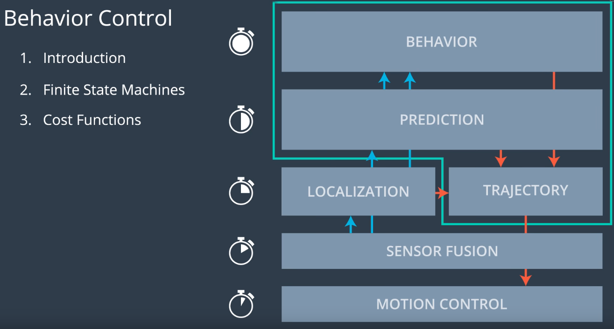

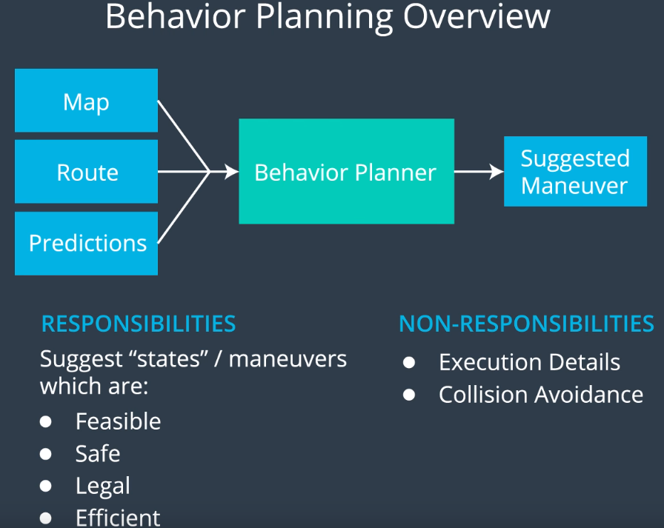

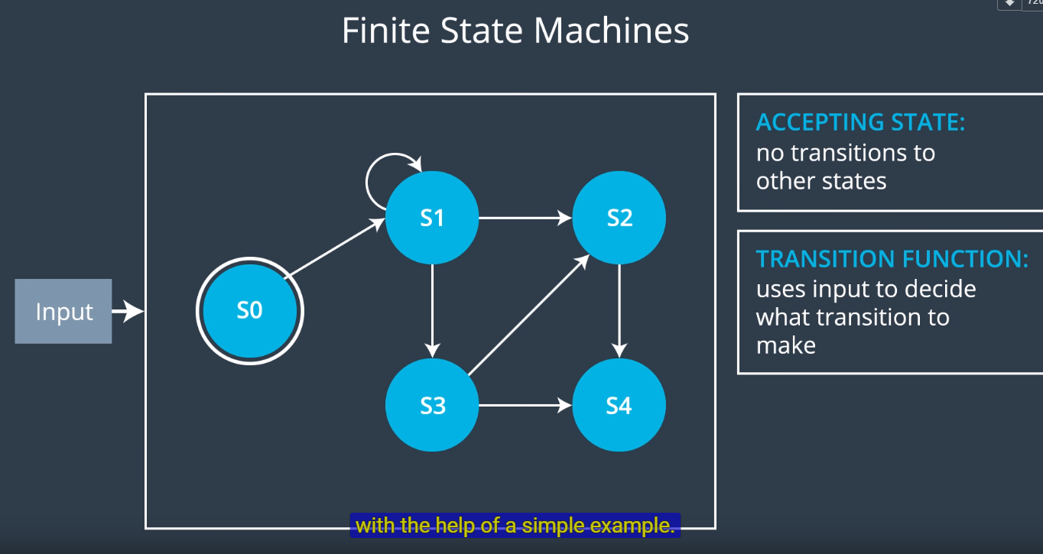

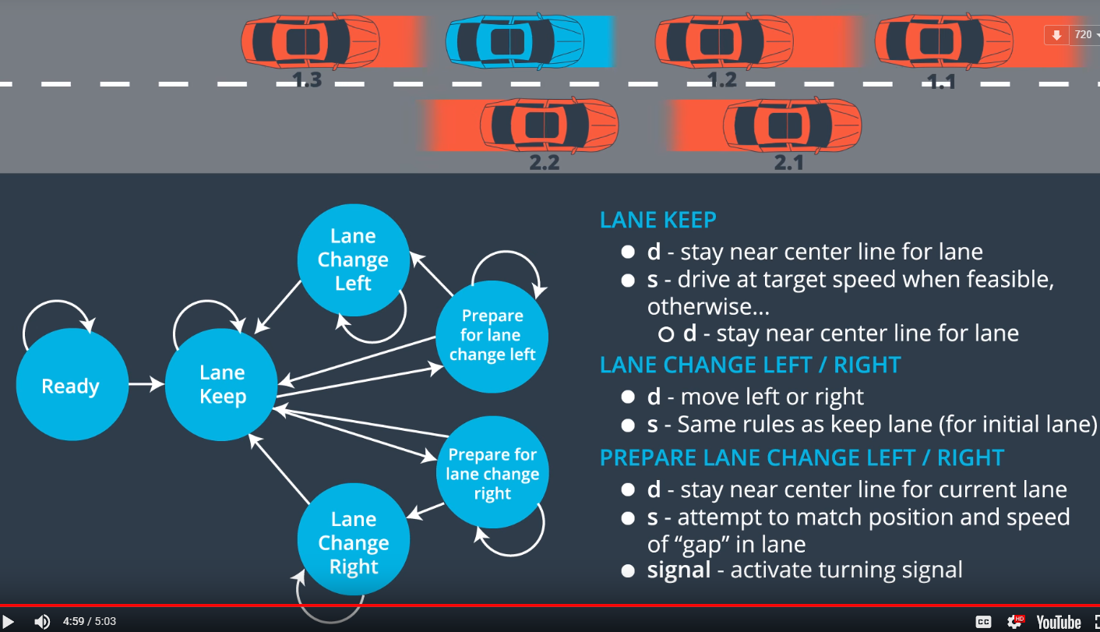

**def** **transition_function**(predictions, current_fsm_state, current_pose, cost_functions, weights):

*# only consider states which can be reached from current FSM state.*

possible_successor_states = successor_states(current_fsm_state)

*# keep track of the total cost of each state.*

costs = []

**for** state **in** possible_successor_states:

*# generate a rough idea of what trajectory we would*

*# follow IF we chose this state.*

trajectory_for_state = generate_trajectory(state, current_pose, predictions)

*# calculate the "cost" associated with that trajectory.*

cost_for_state = 0

**for** i **in** range(len(cost_functions)) :

*# apply each cost function to the generated trajectory*

cost_function = cost_functions[i]

cost_for_cost_function = cost_function(trajectory_for_state, predictions)

*# multiply the cost by the associated weight*

weight = weights[i]

cost_for_state += weight * cost_for_cost_function

costs.append({'state' : state, 'cost' : cost_for_state})

*# Find the minimum cost state.*

best_next_state = **None**

min_cost = 9999999

**for** i **in** range(len(possible_successor_states)):

state = possible_successor_states[i]

cost = costs[i]

**if** cost < min_cost:

min_cost = cost

best_next_state = state

**return** best_next_state

4.11 Cost function for speed penalty

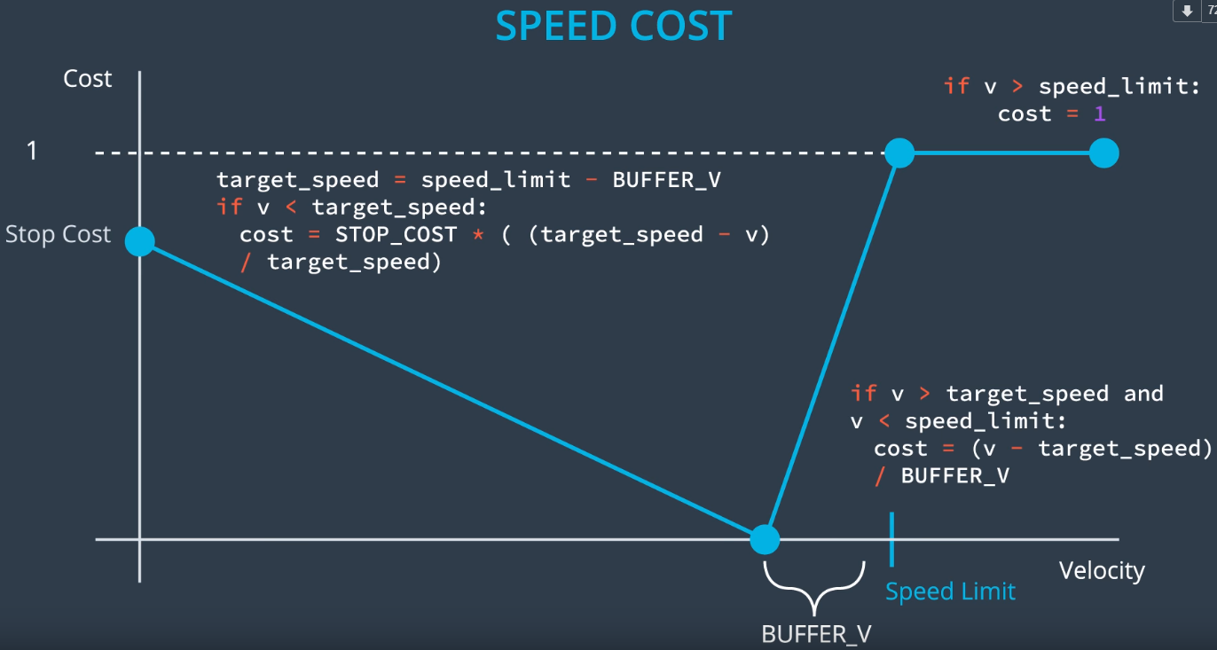

4.12 cost function for lane change

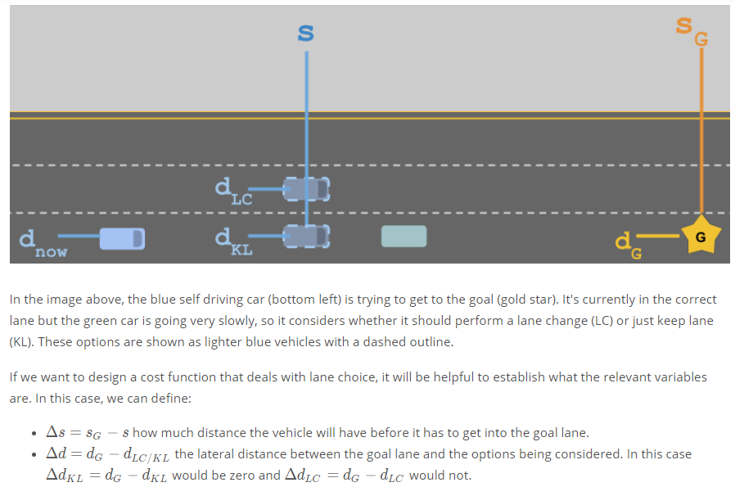

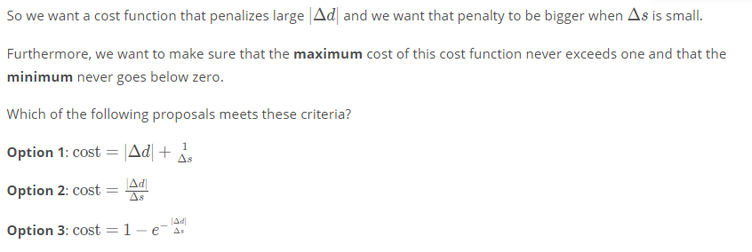

Cost function 1:

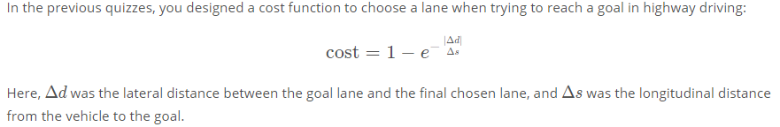

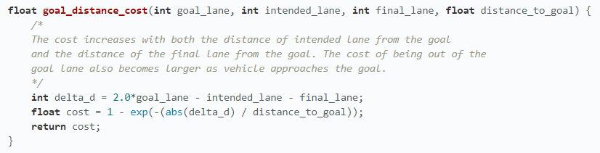

Not related with speed

Cost function 2:

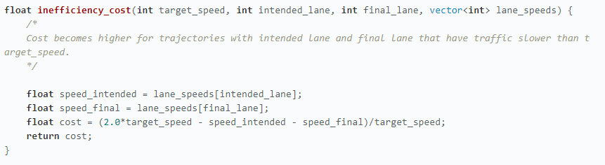

Not related with distance

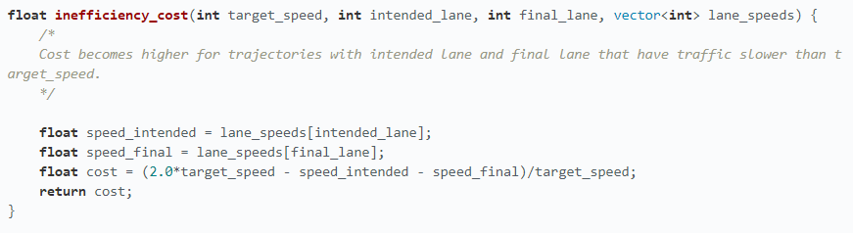

**Combined cost functions**

**Python3**

REACH_GOAL = 10 ** 6

EFFICIENCY = 10 ** 5

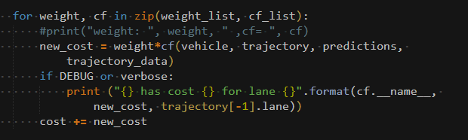

**C++**

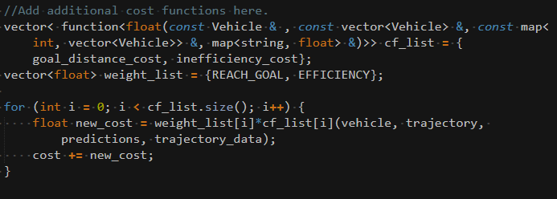

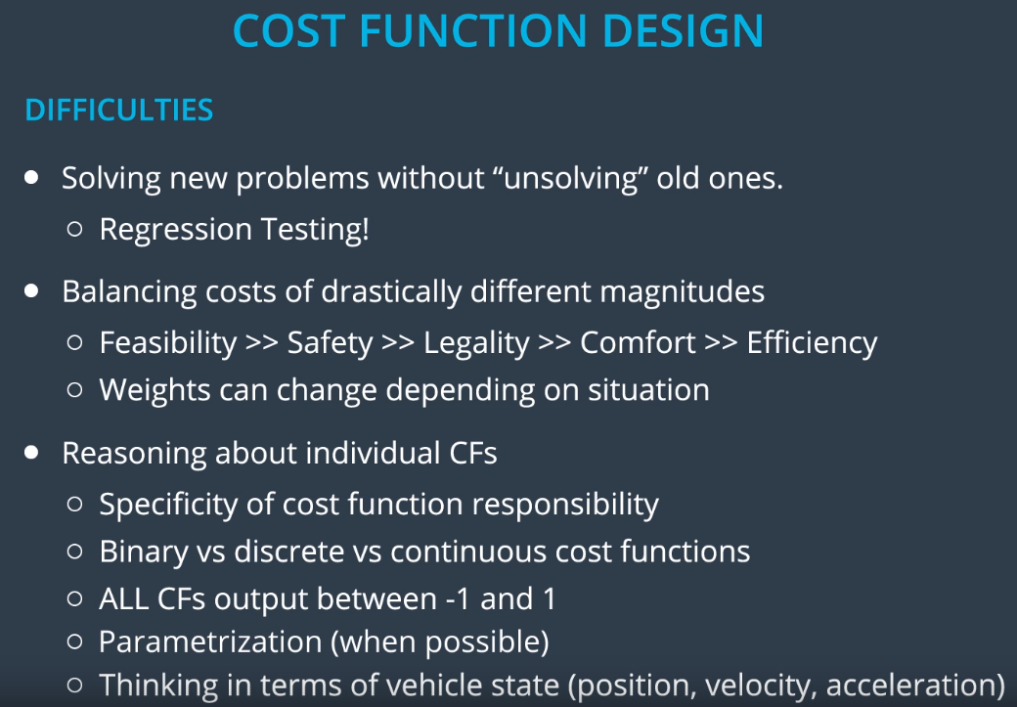

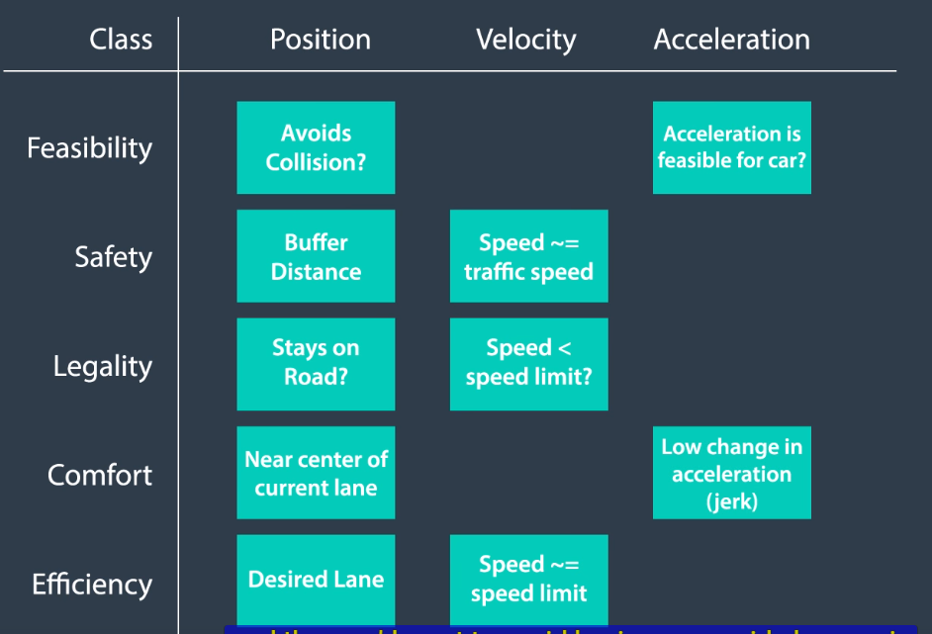

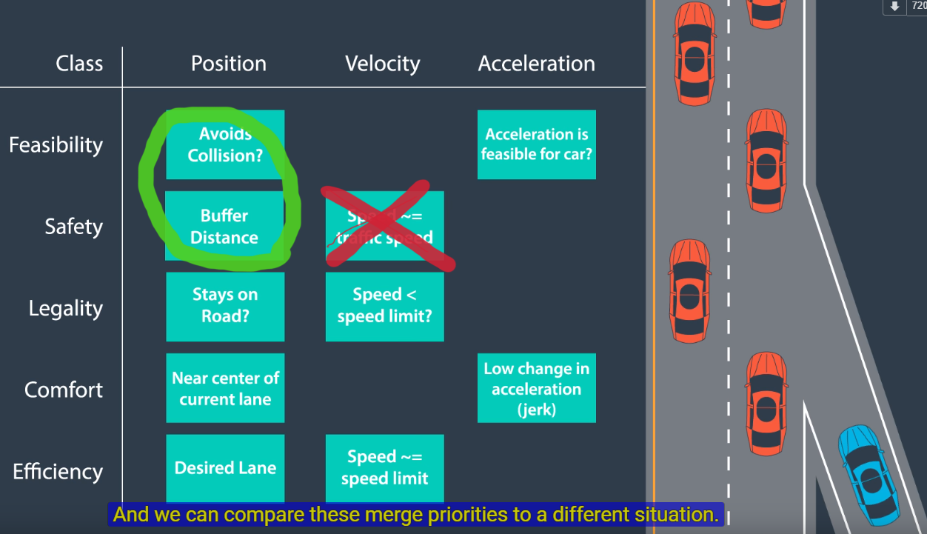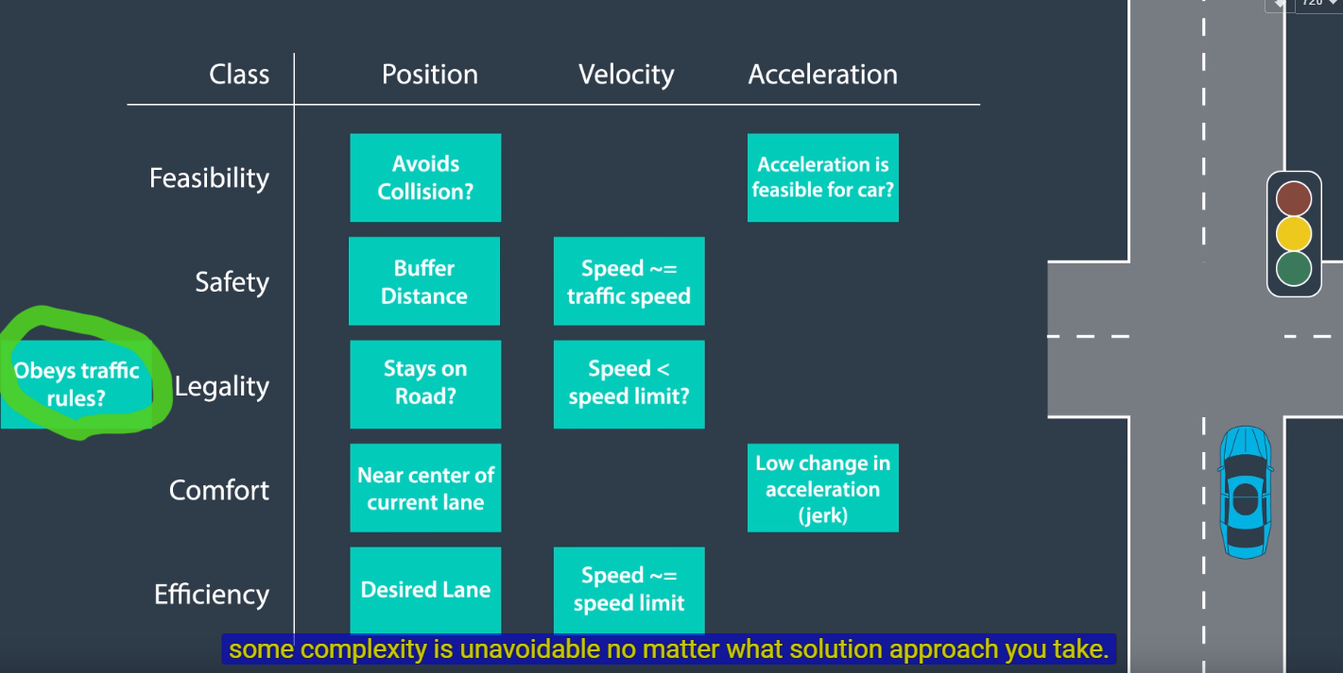

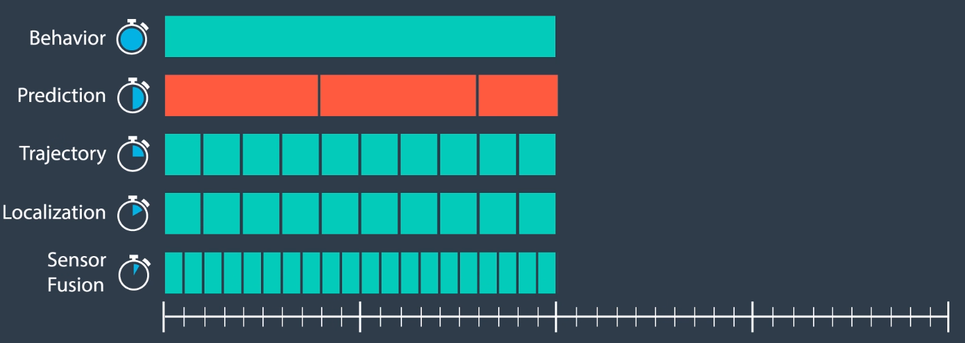

**Highway behavior planning algo**

***5, Trajectory Generation***

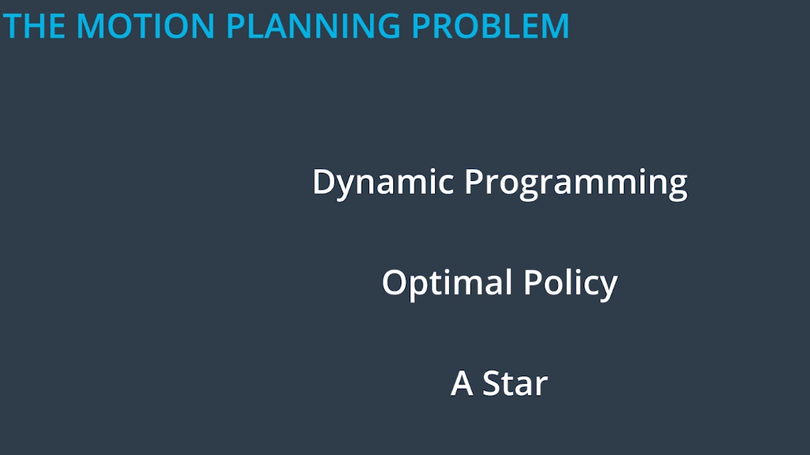

5.2 motion planning problem

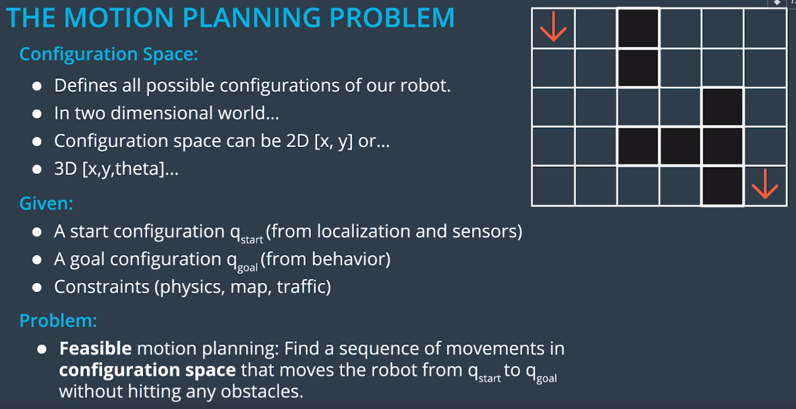

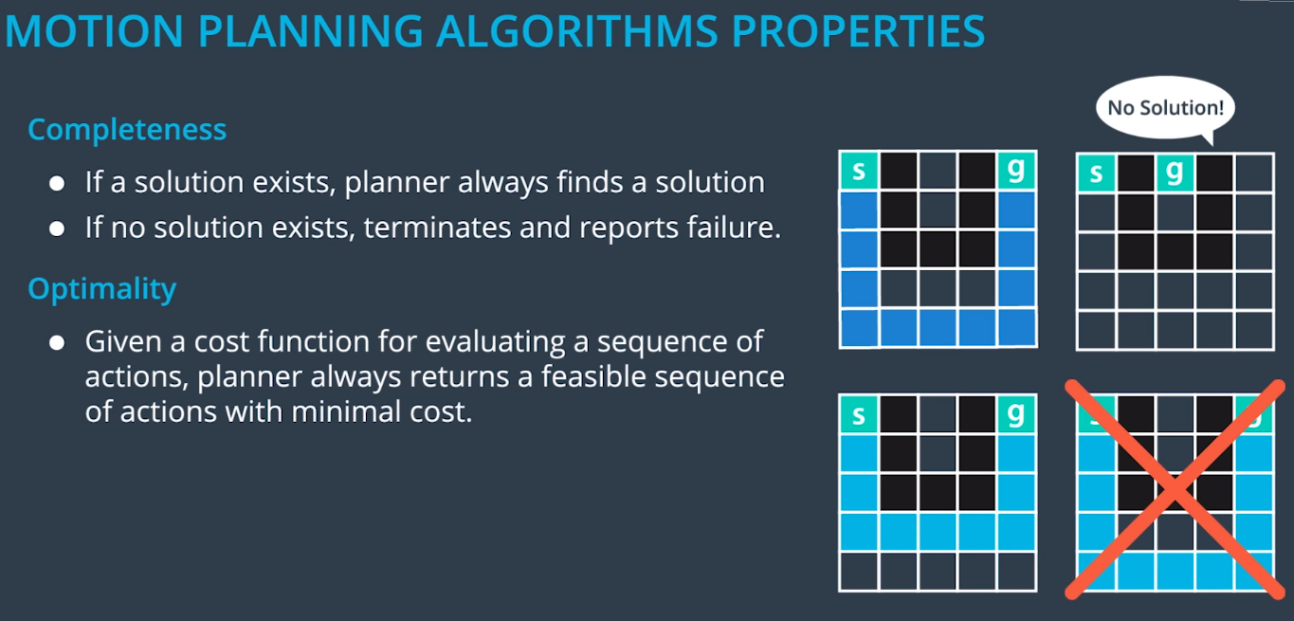

5.4 Classification of planning approaches

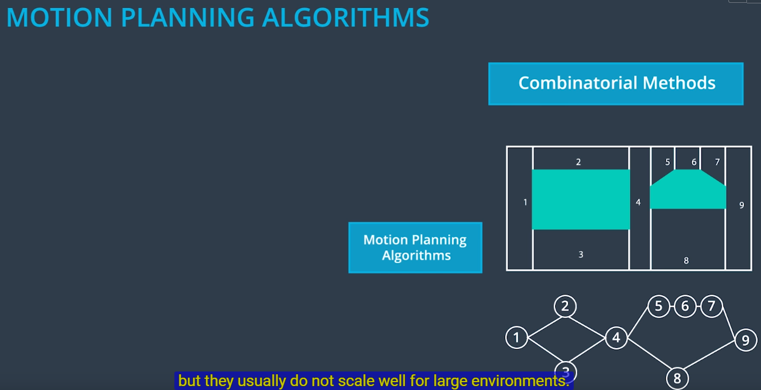

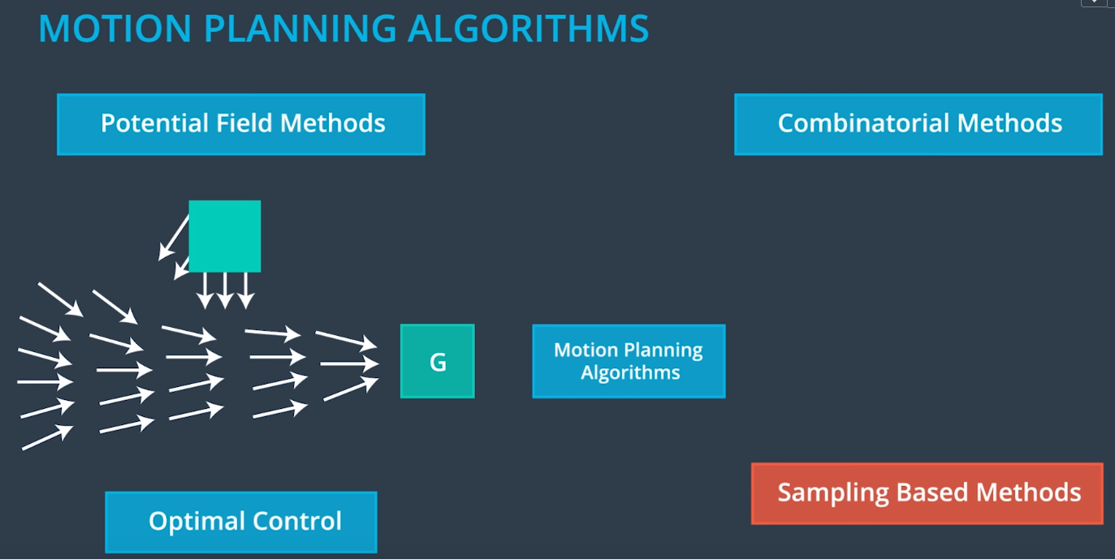

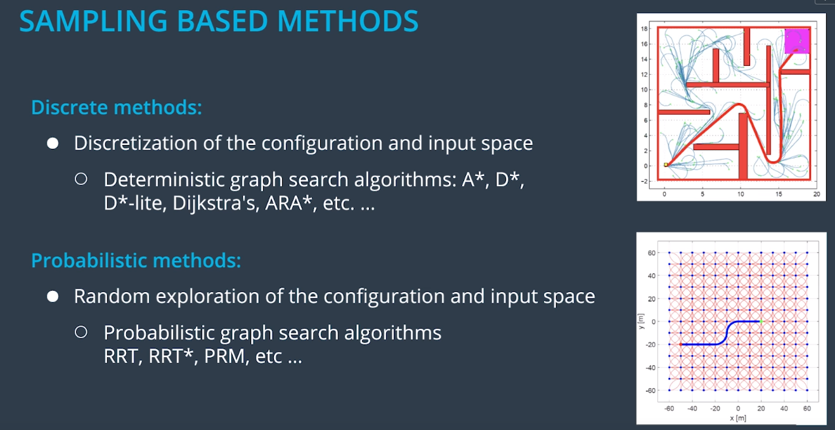

5.5 A*

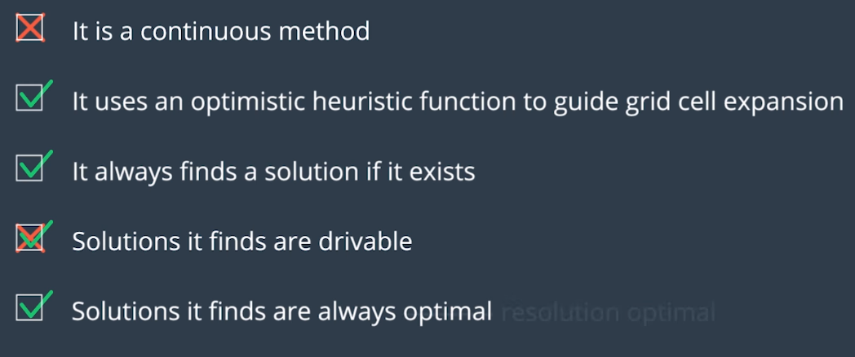

5.7 Hybrid A*

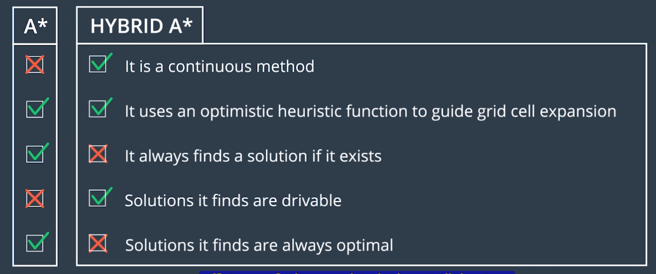

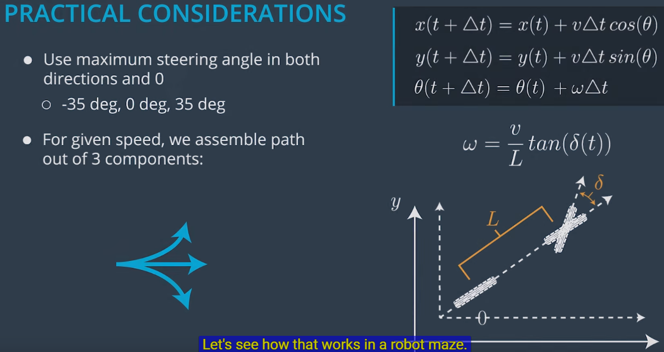

**def expand(state, goal):**

**next_states = []**

**for delta in range(-35, 40, 5):**

***# Create a trajectory with delta as the steering angle using the bicycle model:***

***# ---Begin bicycle model---***

**delta_rad = deg_to_rad(delta)**

**omega = SPEED/LENGTH * tan(delta_rad)**

**next_x = state.x + SPEED * cos(theta)**

**next_y = state.y + SPEED * sin(theta)**

**next_theta = normalize(state.theta + omega)**

***# ---End bicycle model-----***

**next_g = state.g + 1**

**next_f = next_g + heuristic(next_x, next_y, goal)**

***# Create a new State object with all of the "next" values.***

**state = State(next_x, next_y, next_theta, next_g, next_f)**

**next_states.append(state)**

**return next_states**

**def search(grid, start, goal):**

***# The opened array keeps track of the stack of States objects we are***

***# searching through.***

**opened = []**

***# 3D array of zeros with dimensions:***

***# (NUM_THETA_CELLS, grid x size, grid y size).***

**closed = [[[0 for x in range(grid[0])] for y in range(len(grid))] for cell in range(NUM_THETA_CELLS)]**

***# 3D array with same dimensions. Will be filled with State() objects to keep***

***# track of the path through the grid.***

**came_from = [[[0 for x in range(grid[0])] for y in range(len(grid))] for cell in range(NUM_THETA_CELLS)]**

***# Create new state object to start the search with.***

**x = start.x**

**y = start.y**

**theta = start.theta**

**g = 0**

**f = heuristic(start.x, start.y, goal)**

**state = State(x, y, theta, 0, f)**

**opened.append(state)**

***# The range from 0 to 2pi has been discretized into NUM_THETA_CELLS cells.***

***# Here, theta_to_stack_number returns the cell that theta belongs to.***

***# Smaller thetas (close to 0 when normalized into the range from 0 to 2pi)***

***# have lower stack numbers, and larger thetas (close to 2pi whe normalized)***

***# have larger stack numbers.***

**stack_number = theta_to_stack_number(state.theta)**

**closed[stack_number][index(state.x)][index(state.y)] = 1**

***# Store our starting state. For other states, we will store the previous state***

***# in the path, but the starting state has no previous.***

**came_from[stack_number][index(state.x)][index(state.y)] = state**

***# While there are still states to explore:***

**while opened:**

***# Sort the states by f-value and start search using the state with the***

***# lowest f-value. This is crucial to the A* algorithm; the f-value***

***# improves search efficiency by indicating where to look first.***

**opened.sort(key=lambda state:state.f)**

**current = opened.pop(0)**

***# Check if the x and y coordinates are in the same grid cell as the goal.***

***# (Note: The idx function returns the grid index for a given coordinate.)***

**if (idx(current.x) == goal[0]) and (idx(current.y) == goal.y):**

***# If so, the trajectory has reached the goal.***

**return path**

***# Otherwise, expand the current state to get a list of possible next states.***

**next_states = expand(current, goal)**

**for next_state in next_states:**

***# If we have expanded outside the grid, skip this next_state.***

**if next_states is not in the grid:**

**continue**

***# Otherwise, check that we haven't already visited this cell and***

***# that there is not an obstacle in the grid there.***

**stack_number = theta_to_stack_number(next_state.theta)**

**if closed_value[stack_number][idx(next_state.x)][idx(next_state.y)] == 0 and grid[idx(next_state.x)][idx(next_state.y)] == 0:**

***# The state can be added to the opened stack.***

**opened.append(next_state)**

***# The stack_number, idx(next_state.x), idx(next_state.y) tuple***

***# has now been visited, so it can be closed.***

**closed[stack_number][idx(next_state.x)][idx(next_state.y)] = 1**

***# The next_state came from the current state, and that is recorded.***

**came_from[stack_number][idx(next_state.x)][idx(next_state.y)] = current**

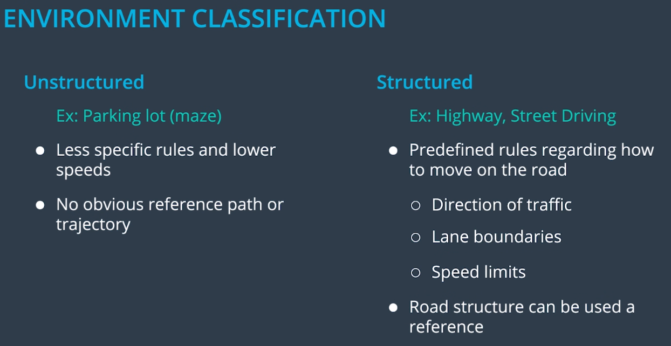



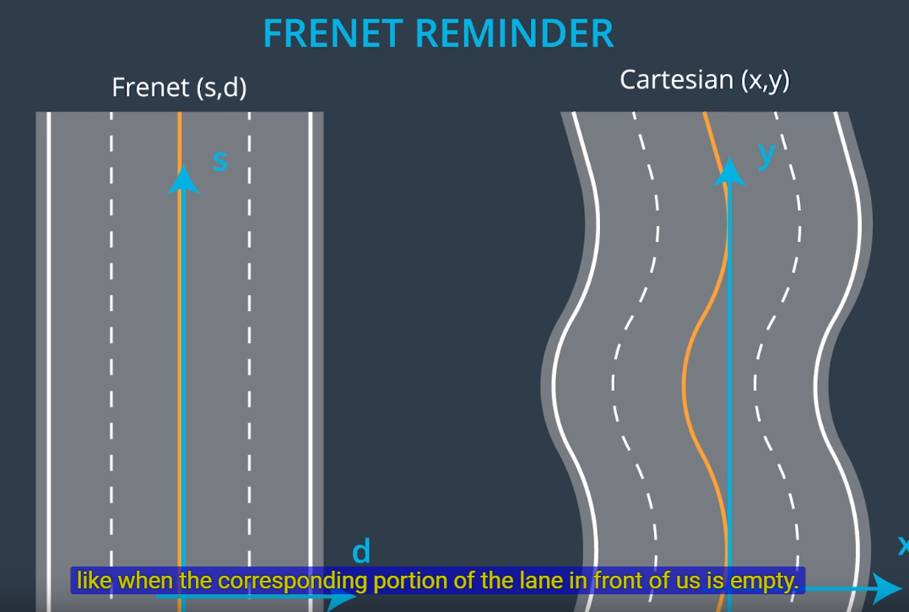

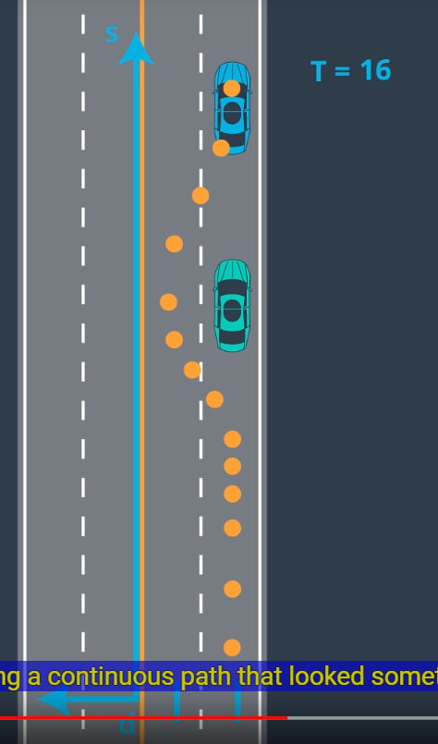

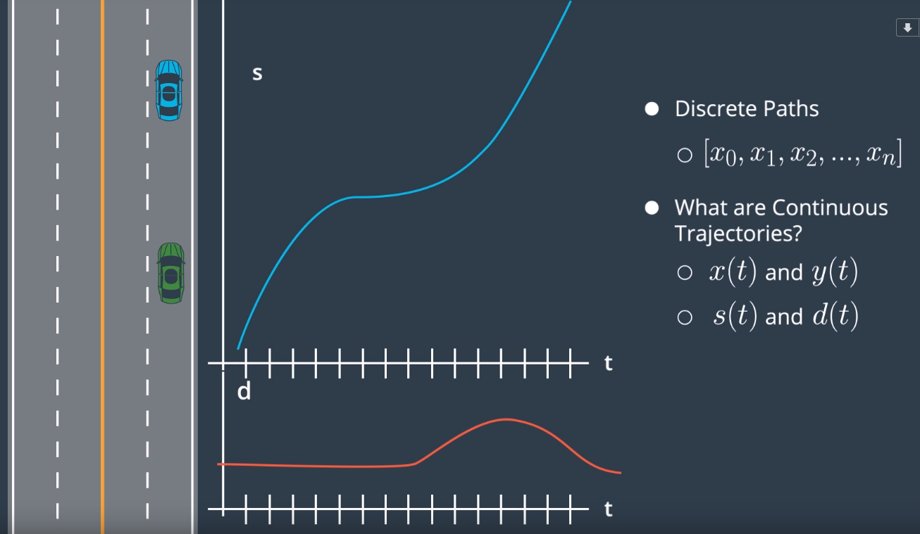

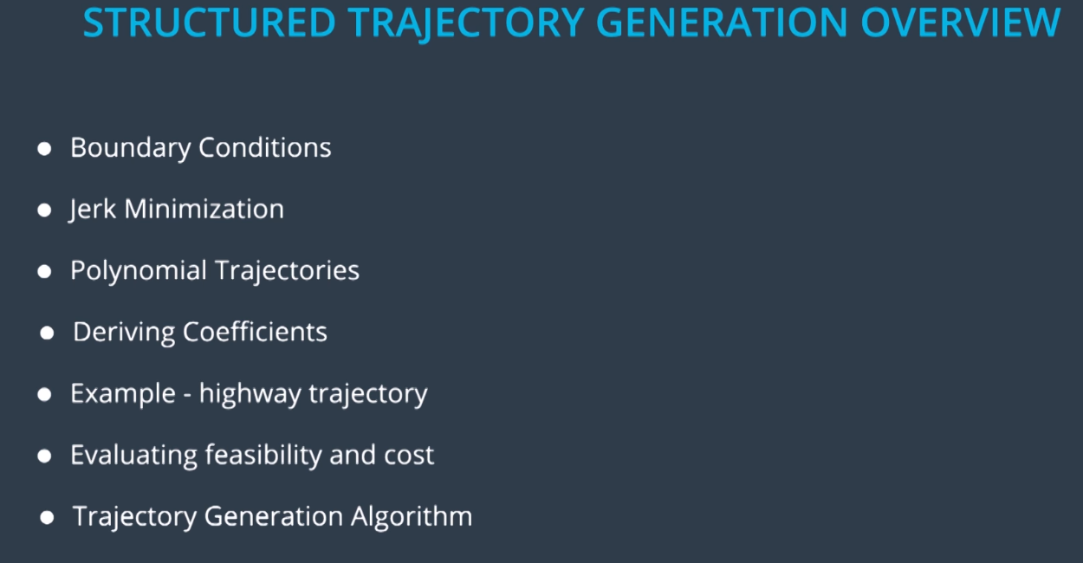

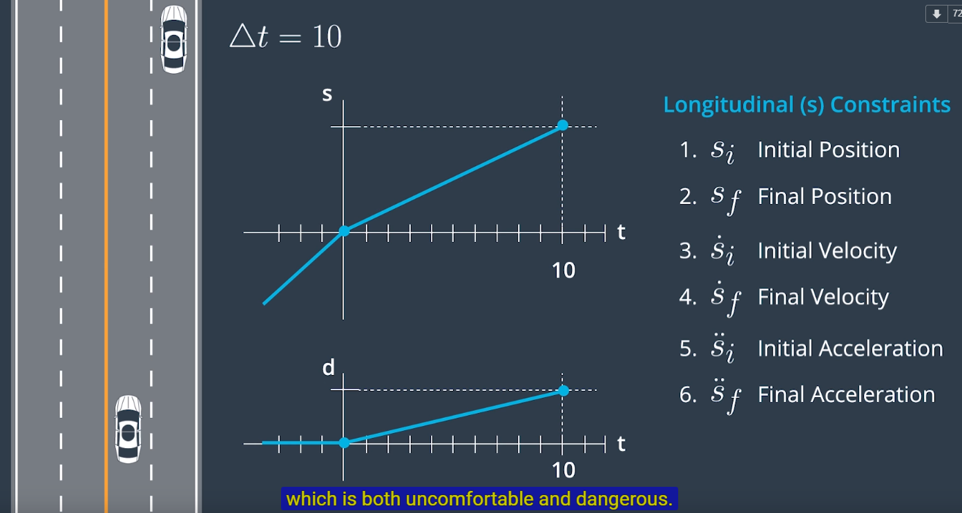

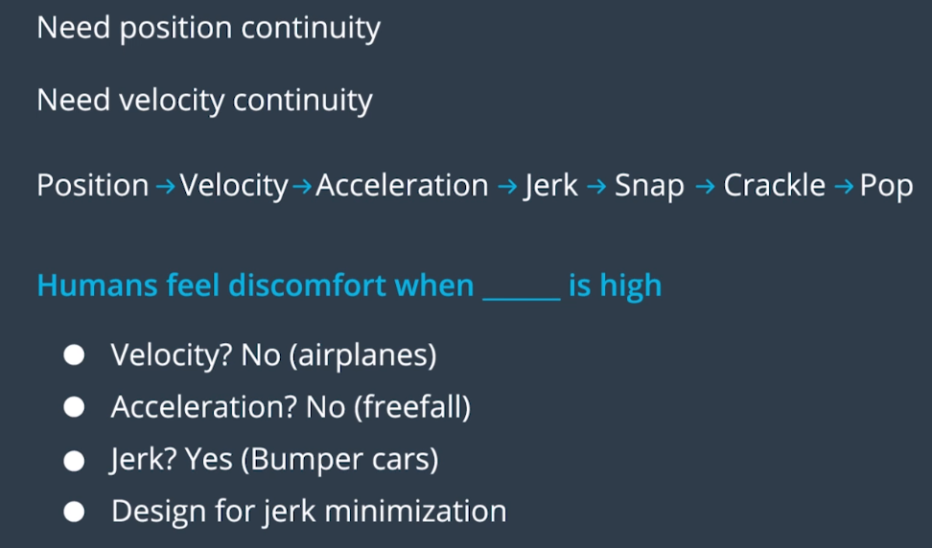

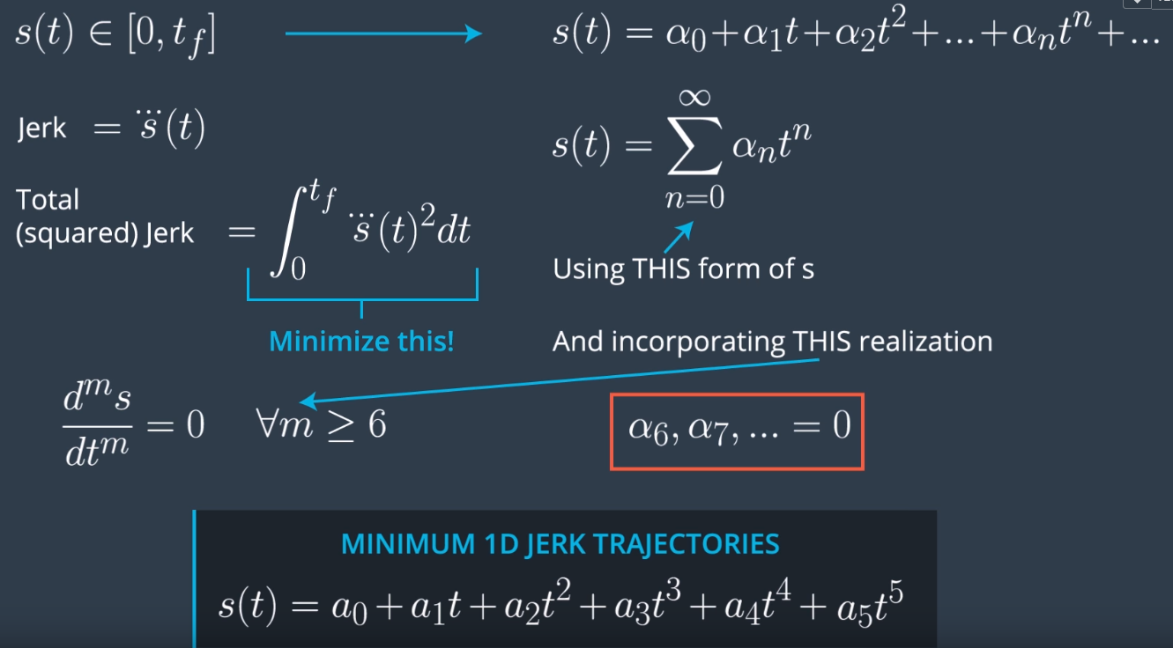

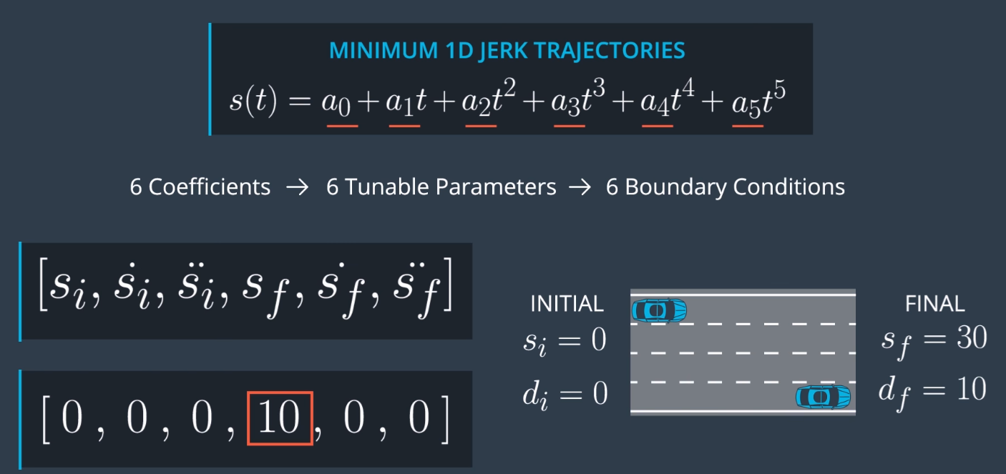

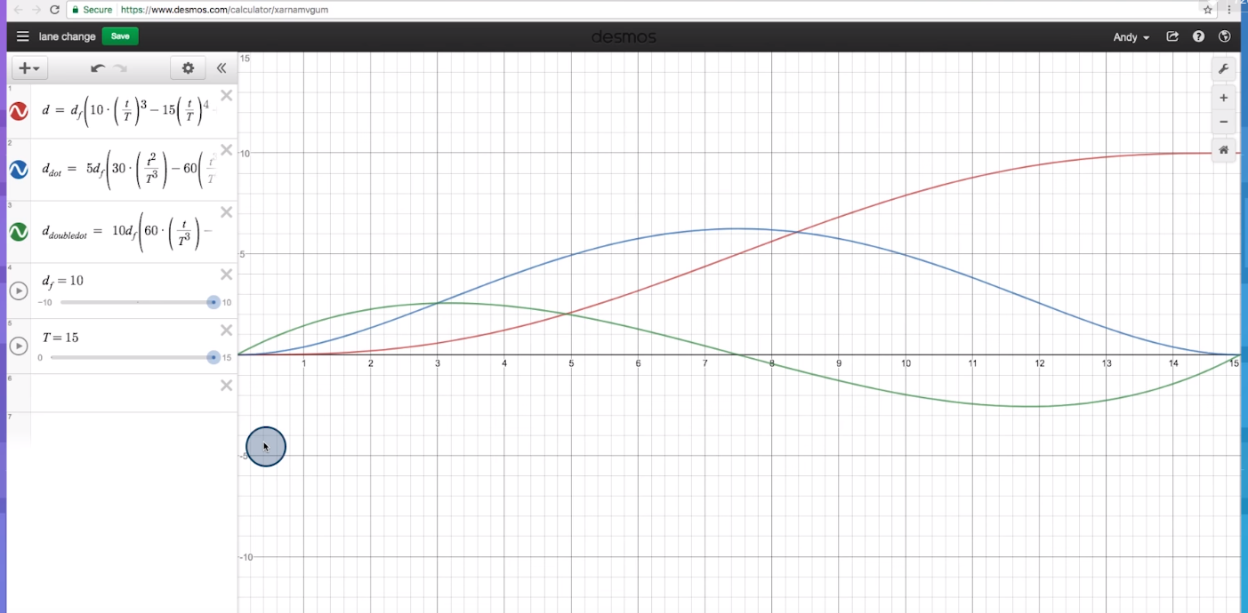

5.25 Sampling based polynomial trajectory genereation

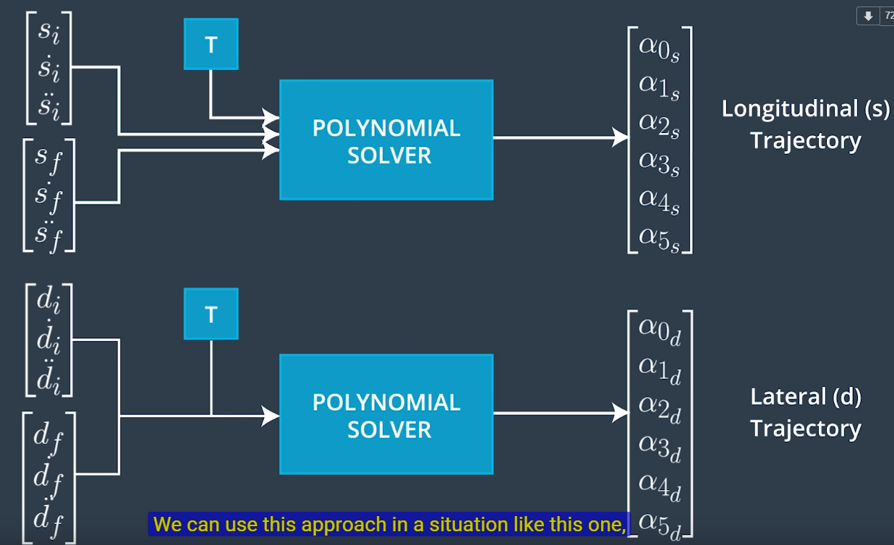

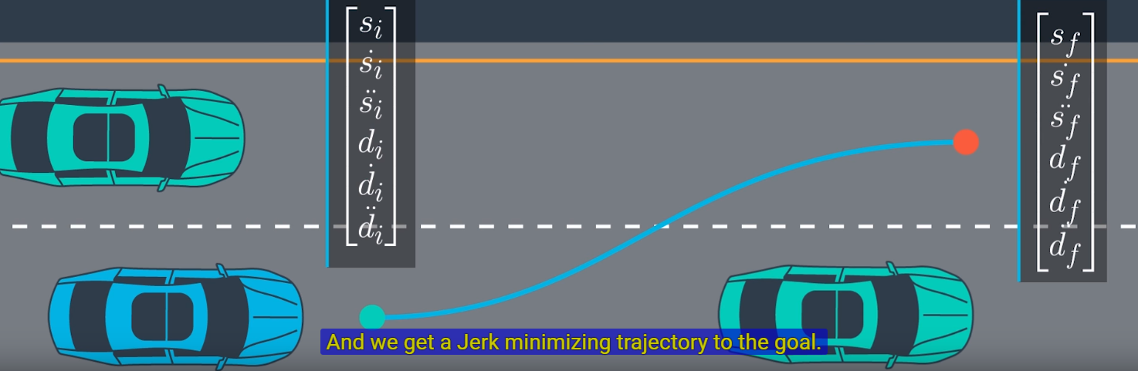

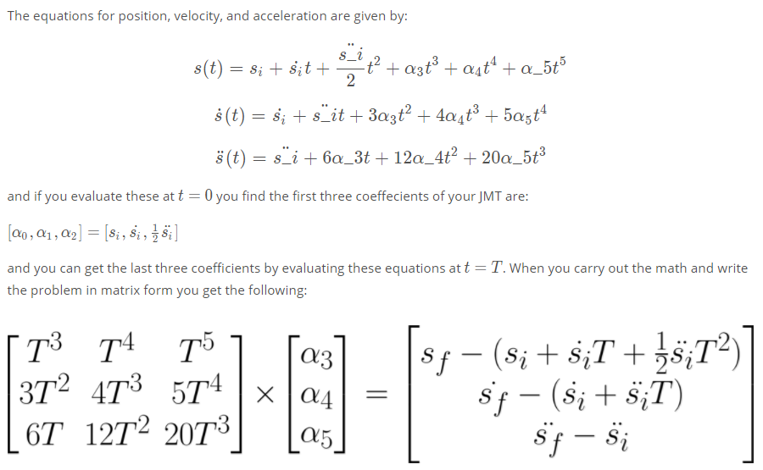

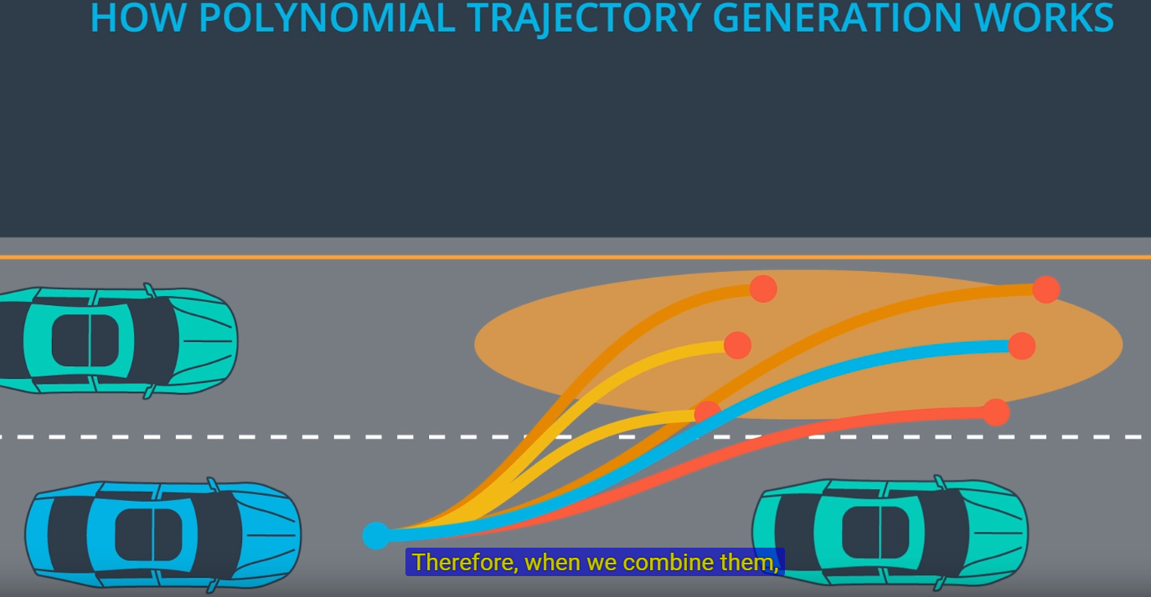

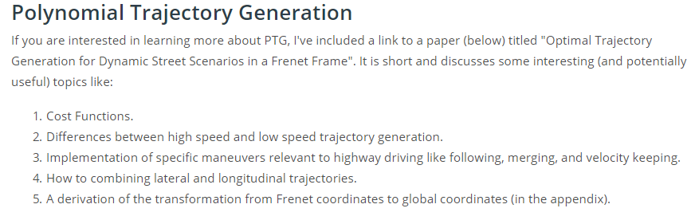

== **run sim calculation/control signals on Linux, but listen to simulator/ generate sim data from windows client** =====

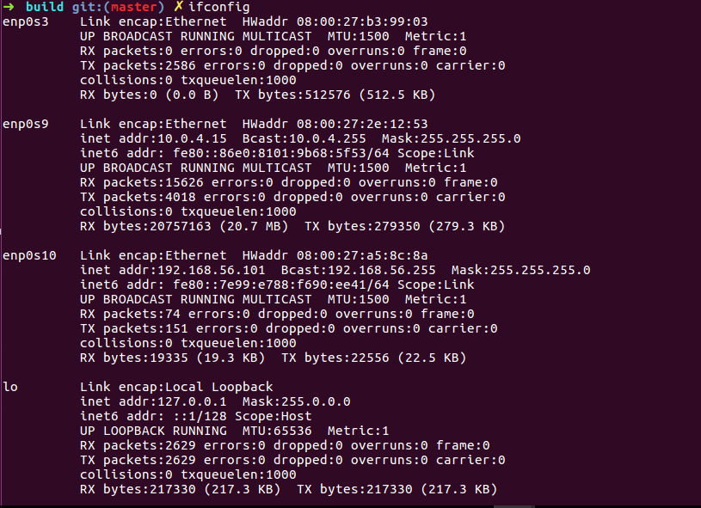

**Administrator:**

Netsh>interface portproxy add v4tov4 listenport=4567 listenaddress=127.0.0.1 connectport=4567 connectaddress=<> protocol=tcp



